Supermarket Sales Data Analysis
1. Business Problem
Supermarkets generate large amounts of sales data containing information about customers, products, branches, payment methods, sales amounts, and ratings. Analyzing this data helps the business understand customer purchasing behavior, identify profitable product categories, compare branch performance, and discover sales trends.
The objective of this project is to analyze the Supermarket Sales Dataset and answer important business questions such as:
- Which branch generates the highest sales?
- Which product line is the most profitable?
- Which payment method is most popular?
- Which month has the highest sales?
- Which day has the highest sales?
- What is the average customer rating?
- Which city generates the highest revenue?
The analysis is performed using Python, Pandas, SQL, Matplotlib, and visualization techniques.

2. Dataset Description
The Supermarket Sales dataset contains sales transactions from different supermarket branches.
Important columns
Column | Description
Invoice ID | Unique invoice number
Branch | Supermarket branch
City | City where the branch is located
Customer type | Member or Normal
Gender | Customer gender
Product line | Category of product purchased
Unit price | Price of one product unit
Quantity | Number of products purchased
Tax 5% | Tax amount
Total | Total transaction amount
Date | Date of transaction
Time | Time of transaction
Payment | Payment method
COGS | Cost of goods sold
Gross margin percentage | Gross margin percentage
Gross income | Profit/gross income
Rating | Customer rating
3. Analysis Goals
The project aims to answer the following questions:
- Which branch has the highest sales?
- Which product line is the most profitable?
- Which payment method is the most popular?
- Which month has the maximum sales?
- Which day of the week has the maximum sales?

Data Cleaning
The dataset was cleaned by removing duplicate records, checking and handling missing values, converting the date column into the correct datetime format, and ensuring that numerical columns such as sales, quantity, and ratings had appropriate data types.

Pandas Analysis
Pandas was used to calculate total and average sales and analyze sales by branch and product line. The analysis also examined monthly and daily sales trends. Product profitability was measured using gross income, while payment method frequency was analyzed to identify the most popular payment method.
SQL Analysis
SQL queries were used to calculate total revenue, identify top-selling product lines, find the highest-performing branch, calculate average customer ratings, and analyze total sales by city.
Charts
Four visualizations were created:
- Bar Chart – Compares sales across different branches.

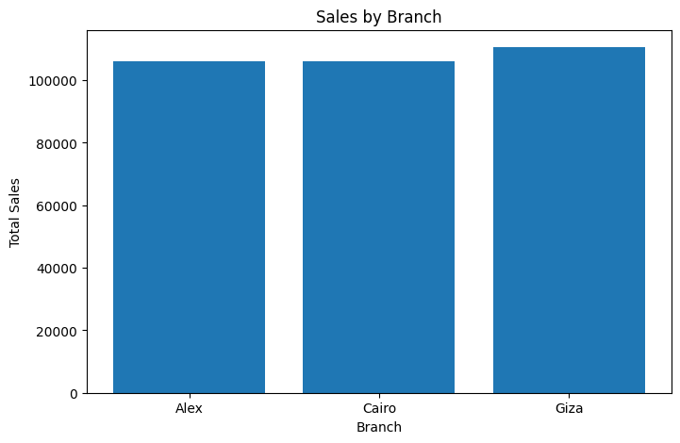

- Pie Chart – Shows the distribution of payment methods.
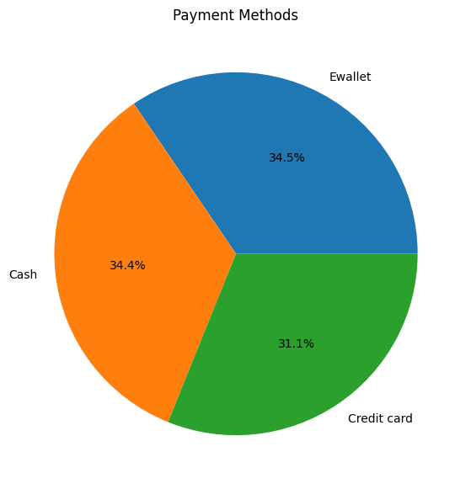.

- Line Chart – Displays monthly sales trends.
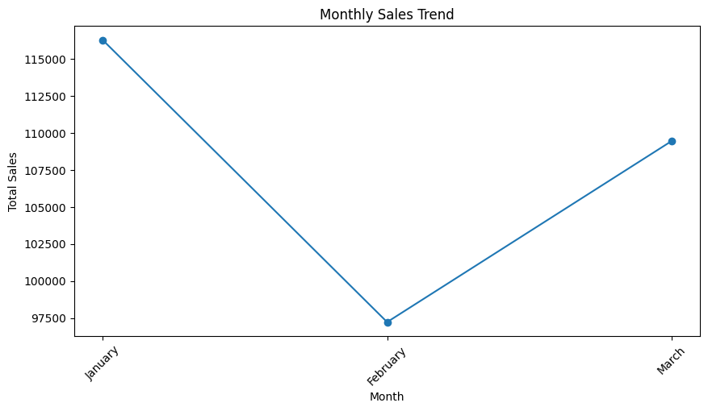

- Histogram – Shows the distribution of customer ratings.

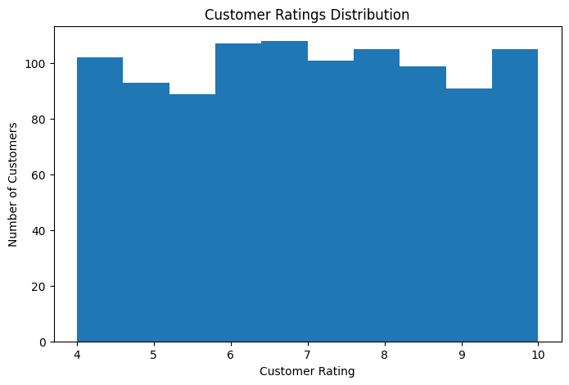

Recommendations
Based on the analysis, the supermarket can:
- Study the strategies of the highest-performing branch and apply successful practices to other branches.
- Promote the most profitable product lines to increase overall profit.
- Maintain sufficient inventory for high-demand products.
- Plan special promotions during months with lower sales.
- Focus marketing campaigns on popular payment methods while continuing to provide multiple payment options.
- Monitor customer ratings and improve service quality where necessary.
- Use customer purchase patterns to create personalized promotions.
- Analyze low-performing branches and product lines to identify opportunities for improvement.

